JSS3

Basic technology E­­­_note

Week 1: revision of last term’s work

Week2: fault detection

_ Definition (trouble shooting)

_ tools for fault detection

Week3: basic electronics

_ Basic electronic devices

_Types of electronics devices

Week4: basic electronics (continues)

_components

_uses

Week5: machine motion

_ linear motion

_linear arrangement to produce linear motion

_use of slides and slots in mechanical system

Week 6: machine motion

_rotary motion

_one way

_reversible rotary motion

7_12 revision & examination.

Week 1 revision

[UPPLIERS](https://www.globalspec.com/productfinder) [MOTION AND CONTROLS](https://www.globalspec.com/productfinder/motion_controls) LINEAR AND ROTARY MOTION COMPONENTS

**Linear and Rotary Motion Components**

Components used in the assembly of linear or rotary motion systems, such as ball screws, lead screws, slides, stages, and actuators.

What are you looking for in Linear and Rotary Motion Components?

[**Air Cylinders**](https://www.globalspec.com/search/products?page=ms&comp=1361&show=products)

Air cylinders are pneumatic linear actuators that are driven by a pressure differential in the cylinder's chambers. They may be single-acting (with a spring return) or double-act

[**Ball Screws**](https://www.globalspec.com/search/products?page=ms&comp=131&show=products)

Ball screws convert rotary motion to linear motion, or torque to thrust, and vice versa. They are primarily a power screw with a train of ball bearings riding between the screw and the nut in a recirculating track.**Ball Slides**

Ball slides are simple linear motion devices that provide smooth linear motion, accurately controlled by the rotation of

[**Ball Splines**](https://www.globalspec.com/search/products?page=ms&comp=144&show=products)

Ball splines provide nearly friction-free linear motion while simultaneously transmitting torsional loads. The path of the bearing balls is straight, not helical, which allows for a very efficient coupling device suitable for a variety of applications.   
[Search by Specification](https://www.globalspec.com/SpecSearch/SearchForm/motion_controls/linear_rotary_motion_components/ball_spline)  |  [Learn more about Ball Splines](https://www.globalspec.com/learnmore/motion_controls/linear_rotary_motion_components/ball_spline)

[**Crossed Roller Slides**](https://www.globalspec.com/search/products?page=ms&comp=3487&show=products)

Crossed roller slides are simple linear motion devices that consist of a stationary base and a moving carriage. The rollers are crossed at a 90° angle in an alternating fashion and are enclosed in the rails, which have a machined V-shaped groove to support the roller

[**Dovetail Slides**](https://www.globalspec.com/search/products?page=ms&comp=3488&show=products)

Dovetail slides are linear motion devices that allow motion and positioning along a linear axis.   
[Search by Specification](https://www.globalspec.com/SpecSearch/SearchForm/motion_controls/linear_rotary_motion_components/dovetail_slides)  |  [Learn more about Dovetail Slides](https://www.globalspec.com/learnmore/motion_controls/linear_rotary_motion_components/dovetail_slides)

[**Electric Rotary Actuators**](https://www.globalspec.com/search/products?page=ms&comp=1445&show=products)

Electric rotary actuators drive components rotationally via electromagnetic power. They typically have control and indexing capabilities.

[**Feed Escapements**](https://www.globalspec.com/search/products?page=ms&comp=5614&show=products)

Feed escapements are used for individually feeding parts from hoppers, conveyors, magazines, tracks, and vibratory feeders.   
 **Hydraulic Cylinders**

Hydraulic cylinders are actuation devices that utilize pressurized hydraulic fluid to produce linear motion and force

[**Hydraulic Rotary Actuators**](https://www.globalspec.com/search/products?page=ms&comp=1363&show=products)

Hydraulic rotary actuators use a pressurized, incompressible fluid to rotate mechanical components.

[**Index Drives**](https://www.globalspec.com/search/products?page=ms&comp=4494&show=products)

Index drives are used to start and stop a table, conveyor or other equipment at precise intervals. Types of index drives include cam index drives, ring index drives, and roller gear i  **Screws and ACME Screws**

Lead screws and ACME screws are used to drive a nut in linear motion via direct contact between the screw and the nut. Lead screws usually incorporate proprietary screw and nut geometries and materials, and can be configured in zero-ba **Linear Actuators**

Electric linear actuators have an output rod that provides linear motion via a motor driven ball screw, lead screw or ACME screw assembly. The actuator's load is attached to the end of a screw

[**Linear Bearings**](https://www.globalspec.com/search/products?page=ms&comp=101&show=products)

Linear bearings are used in applications where a component needs to be moved along a straight line with**Linear Stages**

Linear slides are simple linear motion devices composed of a stationary base and a moving carriage. Linear stages are slides with a drive mechanism that provide controlled, precise pos **Multi-axis Positioning Systems**

Multi-axis positioning systems make use of linear, rotary and goniometric stages, slides and drives in various combinations to create standard and custom positioning systems.

[**Piezoelectric Actuators**](https://www.globalspec.com/search/products?page=ms&comp=3083&show=products)

Piezoelectric actuators are devices that produce a small displacement with a high force capability whe

[**Pneumatic Rotary Actuators**](https://www.globalspec.com/search/products?page=ms&comp=4161&show=products)

Pneumatic rotary actuators use pressurized air to rotate mechanical components.

[**Rack and Pinion Drives**](https://www.globalspec.com/search/products?page=ms&comp=4402&show=products)

Rack and pinion drives use a rotational motor to affect linear motion via a rack and pinion combination. They are used frequently in long-travel applications, such as machine tool table positioning, that require high stiffness and accuracy.

[**Roller Screws**](https://www.globalspec.com/search/products?page=ms&comp=5618&show=products)

Roller screws convert rotary to precise linear motion in a similar manner to ball screws or lead screws.  Due to the greater number of contact points of the rollers compared to balls or thread on thread contact, a roller screw

QUESTIONS

1.Give examples of machines that makes use of linear motion

2.mention 2 machines convert linear to rotary motion in their operations

Week 2. Fault detection

**Fault detection, isolation, and recovery** (**FDIR**) is a subfield of [control engineering](https://en.wikipedia.org/wiki/Control_engineering) which concerns itself with monitoring a system, identifying when a [fault](https://en.wikipedia.org/wiki/Fault_%28technology%29) has occurred, and pinpointing the type of fault and its location. Two approaches can be distinguished: A direct pattern recognition of sensor readings that indicate a fault and an analysis of the discrepancy between the sensor readings and expected values, derived from some model. In the latter case, it is typical that a fault is said to be detected if the discrepancy or *residual* goes above a certain threshold. It is then the task of fault isolation to categorize the type of fault and its location in the machinery. **Fault detection and isolation** (**FDI**) techniques can be broadly classified into two categories. These include model-based FDI and signal processing based FDI

**Model-based**

Example of model-based FDI logic for an actuator in an aircraft elevator [1]mathematical[2][3][4]transients.[[5]](https://en.wikipedia.org/wiki/Fault_detection_and_isolation#cite_note-5)

**Signal processing based FDI**

In signal processing based FDI, some mathematical or statistical operations are performed on the measurements, or some neural network is trained using measurements to extract the information about the fault.

A good example of signal processing based FDI is [time domain reflectometry](https://en.wikipedia.org/wiki/Time_domain_reflectometry) where a signal is sent down a cable or electrical line and the reflected signal is compared mathematically to original signal to identify faults. Spread Spectrum Time Domain Reflectometry, for instance, involves sending down a spread spectrum signal down a wire line to detect wire faults.[[10]](https://en.wikipedia.org/wiki/Fault_detection_and_isolation#cite_note-10) Several clustering methods have also been proposed to identify the novel fault and segment a given signal into normal and faulty segments.[[11]](https://en.wikipedia.org/wiki/Fault_detection_and_isolation#cite_note-11)

**Machine fault diagnosis**

Machine fault diagnosis is a field of [mechanical engineering](https://en.wikipedia.org/wiki/Mechanical_engineering) concerned with finding faults arising in machines. A particularly well developed part of it applies specifically to rotating machinery, one of the most common types encountered. To identify the most probable faults leading to failure, many methods are used for data collection, including [vibration](https://en.wikipedia.org/wiki/Vibration) monitoring, [thermal imaging](https://en.wikipedia.org/wiki/Thermal_imaging), oil particle analysis, etc. Then these data are processed utilizing methods like [spectral analysis](https://en.wikipedia.org/wiki/Frequency_spectrum#Spectrum_analysis), [wavelet analysis](https://en.wikipedia.org/wiki/Wavelet_analysis), wavelet transform, short term Fourier transform, Gabor Expansion, Wigner-Ville distribution (WVD), cepstrum, bispectrum, correlation method, high resolution spectral analysis, waveform analysis (in the time domain, because spectral analysis usually concerns only frequency distribution and not phase information) and others. The results of this analysis are used in a root cause failure analysis in order to determine the original cause of the fault. For example, if a bearing fault is diagnosed, then it is likely that the bearing was not itself damaged at installation, but rather as the consequence of another installation error (e.g., misalignment) which then led to bearing damage. Diagnosing the bearing's damaged state is not enough for precision maintenance purposes. The root cause needs to be identified and remedied.

proach for machine fault diagnosis can be divided into two broad categories: linear methods and the quadratic methods. The difference is that linear transforms can be inverted to construct the time signal, thus, they are more suitable for signal processing, such as noise reduction and time-varying filtering. Although the quadratic method describes the energy distribution of a signal in the joint time frequency domain, which is useful for analysis, classification, and detection of signal features, phase information is lost in the quadratic time-frequency representation; also, the time histories cannot be reconstructed with

**Robust fault diagnosis**

In practice, model uncertainties and measurement noise can complicate fault detection and isolation.[[12]](https://en.wikipedia.org/wiki/Fault_detection_and_isolation#cite_note-12)

As a result, using fault diagnostics to meet industrial needs in a cost-effective way, and to reduce maintenance costs without requiring more investments than the cost of what is to be avoided in the first place, requires an effective scheme of applying them. This is the subject of [maintenance, repair and operations](https://en.wikipedia.org/wiki/Maintenance,_repair_and_operations); the different strategies include:

* [Condition-based maintenance](https://en.wikipedia.org/wiki/Condition-based_maintenance)
* [Planned preventive maintenance](https://en.wikipedia.org/wiki/Planned_maintenance)
* [**Preventive maintenance**](https://en.wikipedia.org/wiki/Preventive_maintenance)
* [**Corrective maintenance**](https://en.wikipedia.org/wiki/Corrective_maintenance) **(does not use diagnostics)**
* [**Integrated vehicle health management**](https://en.wikipedia.org/wiki/Integrated_vehicle_health_management)
* **Questions**
* 1. Explain how fault can be detected in machine
* 2. Identify 2 methods of fult detection

**Week 3 basic** Electronics

# Electron Emission and its Types

### ****What is Electron Emission?****

Metals have free electrons that can move from one atom to the other within the metal. In fact, this factor is responsible for their excellent electrical conductivity. But if they try to escape the metal surface, they are unable to do so. This is because when these negatively charged particles (electrons) try to leave the metal, the surface of the metal acquires positive charge. Due to the attraction between the negative and the positive charges, the electrons are pulled back into the metal. And there are no forces to pull them forward. The electrons are thus forced to stay inside the metal due to the attractive forces. This barrier provided by the metal surface to prevent escaping of free electrons is called the surface barrier.

However, the surface barrier can be broken by providing a certain minimum amount of [energy](https://byjus.com/physics/energy/) to the free electrons which increases their kinetic energy, and consequently help them escape the metal surface. This minimum amount of energy is known as the work function of the metal. And when the work function is provided to the metal, the consequent liberation of electrons from the metal surface is known as electron emission.

Work function of a metal depends on:

* The properties of the metal
* The purity of the metal
* The nature of the metal surface

### ****Types of Electron Emission:****

The electron emission is possible only if sufficient energy (equal to the work function of the metal) is supplied to the metal in the form of heat energy, light energy, etc. Depending on the source of energy, electron emission can be of the following types:

* **Thermionic Emission**: In this type, the metal is heated to a sufficient [temperature](https://byjus.com/physics/temperature/) to enable the free electrons to come out of its surface.
* **Field Emission**: In this type, a very strong electric field is applied to the metal which pulls the electrons out of the surface due to attraction of the positive field.
* **Photoelectric Emission**: In this type, light of certain frequency is made to fall on the metal surface which leads to the emission of electrons.

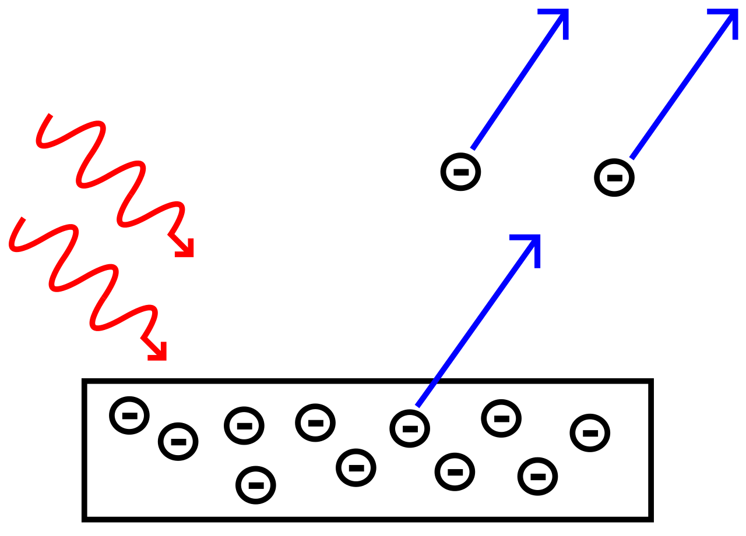

Photoelectric Emission

Stay tuned with byju’s to learn more about electron emission and other concepts in quantum mechanics with interesting video lectures

QUESTIONS

1.List 4 types of methods of liberating electrons

2. explain thermionic emission

|  |  |  |  |
| --- | --- | --- | --- |
|  |  |  |  |

Top of Form

Week4

Components of electronics

|  |  |
| --- | --- |
| [https://upload.wikimedia.org/wikipedia/en/thumb/9/99/Question_book-new.svg/50px-Question_book-new.svg.png](https://en.wikipedia.org/wiki/File:Question_book-new.svg) |  |

[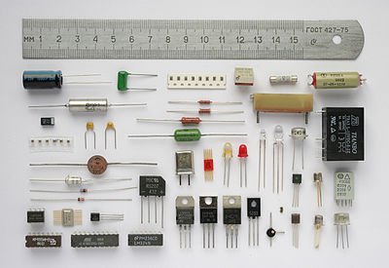](https://en.wikipedia.org/wiki/File:Componentes.JPG)

Various electronic components.

An **electronic component** is any basic **discrete device** or physical entity in an [electronic system](https://en.wikipedia.org/wiki/Electronics) used to affect [electrons](https://en.wikipedia.org/wiki/Electrons) or their associated [fields](https://en.wikipedia.org/wiki/Electromagnetic_field). Electronic components are mostly [industrial products](https://en.wikipedia.org/wiki/Industrial_product), available in a singular form and are not to be confused with [electrical elements](https://en.wikipedia.org/wiki/Electrical_element), which are conceptual abstractions representing idealized electronic components.

Electronic components have a number of [electrical terminals](https://en.wikipedia.org/wiki/Electrical_terminal) or [leads](https://en.wikipedia.org/wiki/Lead_%28electronics%29). These leads connect to create an [electronic circuit](https://en.wikipedia.org/wiki/Electrical_network) with a particular function (for example an [amplifier](https://en.wikipedia.org/wiki/Amplifier), [radio receiver](https://en.wikipedia.org/wiki/Receiver_%28radio%29), or [oscillator](https://en.wikipedia.org/wiki/Electronic_oscillator)). Basic electronic components may be packaged discretely, as arrays or networks of like components, or integrated inside of packages such as [semiconductor](https://en.wikipedia.org/wiki/Semiconductor) [integrated circuits](https://en.wikipedia.org/wiki/Integrated_circuit), [hybrid integrated circuits](https://en.wikipedia.org/wiki/Hybrid_integrated_circuit), or [thick film](https://en.wikipedia.org/wiki/Thick_film_technology) devices. The following list of electronic components focuses on the discrete version of these components, treating such packages as compo

Various electronic components.

An **electronic component** is any basic **discrete device** or physical entity in an [electronic system](https://en.wikipedia.org/wiki/Electronics) used to affect [electrons](https://en.wikipedia.org/wiki/Electrons) or their associated [fields](https://en.wikipedia.org/wiki/Electromagnetic_field). Electronic components are mostly [industrial products](https://en.wikipedia.org/wiki/Industrial_product), available in a singular form and are not to be confused with [electrical elements](https://en.wikipedia.org/wiki/Electrical_element), which are conceptual abstractions representing idealized electronic components.

Electronic components have a number of [electrical terminals](https://en.wikipedia.org/wiki/Electrical_terminal) or [leads](https://en.wikipedia.org/wiki/Lead_%28electronics%29). These leads connect to create an [electronic circuit](https://en.wikipedia.org/wiki/Electrical_network) with a particular function (for example an [amplifier](https://en.wikipedia.org/wiki/Amplifier), [radio receiver](https://en.wikipedia.org/wiki/Receiver_%28radio%29), or [oscillator](https://en.wikipedia.org/wiki/Electronic_oscillator)). Basic electronic components may be packaged discretely, as arrays or networks of like components, or integrated inside of packages such as [semiconductor](https://en.wikipedia.org/wiki/Semiconductor) [integrated circuits](https://en.wikipedia.org/wiki/Integrated_circuit), [hybrid integrated circuits](https://en.wikipedia.org/wiki/Hybrid_integrated_circuit), or [thick film](https://en.wikipedia.org/wiki/Thick_film_technology) devices. The following list of electronic components focuses on the discrete version of these components, treating such packages as components in their owner right

Question

1.list 5 componects of electronis

2.what is the function of amplier

|  |  |
| --- | --- |
| [https://upload.wikimedia.org/wikipedia/en/thumb/9/99/Question_book-new.svg/50px-Question_book-new.svg.png](https://en.wikipedia.org/wiki/File:Question_book-new.svg) |  |

|  |  |
| --- | --- |
| [https://upload.wikimedia.org/wikipedia/en/thumb/9/99/Question_book-new.svg/50px-Question_book-new.svg.png](https://en.wikipedia.org/wiki/File:Question_book-new.svg) |  |

|  |  |
| --- | --- |
| [https://upload.wikimedia.org/wikipedia/en/thumb/9/99/Question_book-new.svg/50px-Question_book-new.svg.png](https://en.wikipedia.org/wiki/File:Question_book-new.svg) |  |

Week 5 and 6 machine motion

# Rotary to Linear Motion

A slider-crank mechanism is a typical design which converts [rotary motion](https://us.misumi-ec.com/vona2/mech/M0100000000/) into [linear motion](https://us.misumi-ec.com/vona2/mech/M0800000000/). It is achieved by connecting a slider and a crank with a [rod](https://us.misumi-ec.com/vona2/result/?Keyword=Rod). This mechanism is also utilized as a system that converts the reciprocating linear motion of an automobile engine into rotary motion.

The second figure (Fig b) is an example of the mechanism that has the same functions as the slider-crank in the first figure (Fig a) in addition to the sliding stroke adjustment feature for the slider. To add this feature, the sliding stroke adjusting screw is placed on top of the rotation shaft center of the rotation disk. The sliding stroke can be adjusted by the adjusting nut located on one end of the sliding stroke adjusting screw.

In addition, if high-speed rotation or operation for long hours is required, it is necessary to consider design items related to the reliability matters described here.

|  |  |  |
| --- | --- | --- |
|  | 1. | Rotation balance of rotating body (the entire structures on the disk) |
|  | 2. | Strength of rotating shaft |
|  | 3. | Prevention of adjusting nut-loosening (e.g. double-nut system) |
|  | 4. | Selection of wear-resistance parts for the area subject to wear |

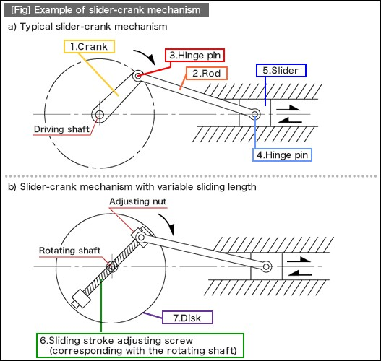  
The figure below illustrates the mechanism with exchangeable rod/slider parts. A U-shaped hook is installed so that the tip of the rod can be easily connected to the hinge pin at the hinged end of the crank.

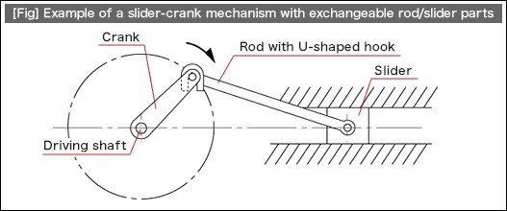

#### Application Examples

For simple automation devices or fixtures made compatible with multiple models by connecting a processing unit to the slider unit, exchanging the slider unit after preparing a processing unit off-line can minimize the time required for mode switching.

|  |  |  |
| --- | --- | --- |
|  | 1. | The drive mechanism of the squeegee unit for a simple screen printing machine: When materials are replaced owing to the pot life or when printing materials are replaced, it is possible to switch models quickly if you remove the slider parts with the squeegee integrated and exchange it with the slider parts with its squeegee position adjusted off-line. |
|  | 2. | Simple press mechanism with multi-model compatibility |

#### http://blog.misumiusa.com/wp-content/uploads/2017/11/RotaryLinear7.gif

#### Application Challenges

Because of this simple coupling method, where only a U-shaped hook is placed over the rotating crank, this mechanism is not compatible with the following types of motion:

|  |  |  |
| --- | --- | --- |
|  | 1. | A high-speed rotating crank. The self-weight of the rod may not be sufficient to follow the motion. |
|  | 2. | A large rotating radius. Motion from the crankshaft to the U-shaped hook will not be transmitted effectively in some areas. |
|  | 3. | Motion involving unstable speed or oscillation. The U-shaped hook may fall off. |

#### How to use a slider-crank mechanism

Below is an automation clever mechanism that converts crank rotation into linear motion and makes the linear motion stroke twice that of the original one.

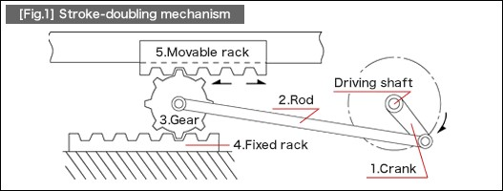

In this structure, the slider used in the standard slider crank mechanism a toothed gear. In addition, the slider guide is separated into a fixed rack and a movable rack. The crank motion on the driving shaft is transmitted to the toothed gear. Then, the stroke of rolling motion (L) over the fixed rack increases by 100% (2L) when it reaches the gear top. This stroke (2L) acts on the movable rack installed on the gear top.

#### More Application Examples

The structure tends to be longer than originally intended if a pneumatic cylinder and a linear guide are used or if a structure where ball screws are used for connecting a motor is adopted. This automation clever mechanism is an effective solution for making the fixture short and compact.

1. Oscillating motion of a processing machine
2. Reciprocating linear motion mechanism for one-piece flow production fixture  
   (printing, wiping, and pressuring)
3. Inspection jigs

Rotary motion can be converted into linear motion by using a screw. This volume introduces an automation clever mechanism that allows control of linear motion in various ways by adopting different types of screw structures. “Threaded” and “tapped” screws are used as a cam.

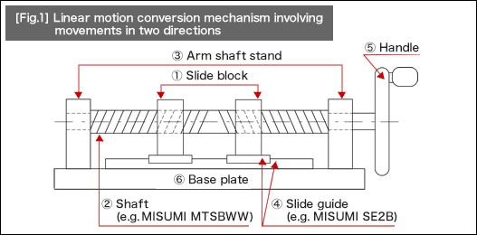

If the handle installed on the right edge is rotated, it causes a linear motion of the slide block placed on the two tapped screws that are assembled to the opposing two screws. This structure can also be applied for a double-speed mechanism, where single rotation of the handle is transformed into a movement of twice the pitch of the rotation.

#### Application Examples

|  |  |  |
| --- | --- | --- |
|  | 1. | Electric terminal positioning or scanning movement for inspection equipment |
|  | 2. | Adjustment mechanism for edge positioning of jigs compatible with various products |
|  | 3. | Double-speed mechanism |

#### Cams

A cam is the typical mechanical component used in the rotary-linear motion conversion mechanism. In this volume, we will look into application examples of the cam.

Cams are the excellent choice because of the following characteristics:

|  |  |  |
| --- | --- | --- |
|  | 1. | Motion characteristics as speed, acceleration, and forces can be freely controlled by the output end to which the cam motion is transmitted. |
|  | 2. | When combined with the link mechanism, incorporating a cam into the structure allows you to design a compact, lightweight yet highly rigid mechanism in a simple structure. |
|  | 3. | Cams can shorten the overall cycle time as they can overlap and control multiple movements. |
|  | 4. | Highly reliable. |

Based on these characteristics, cams are adopted in various applications including the terminal press-fitting mechanism of a high-speed terminal press-fitting machine, as well as the high-speed and complex timing control of an air release valve for an automobile engine. (See [Photo 1].) In the photo below, displacement of the plate cam is enlarged by the link mechanism. To ensure the high-speed responses, springs to prevent jumping have been installed.

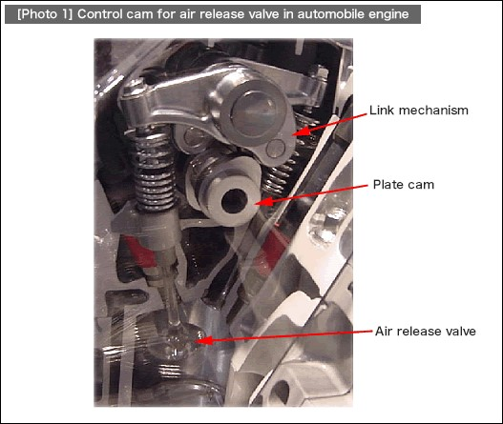

A cam introduced here as the basics of automation clever mechanisms works as a supportive element that allows for quick attachment/detachment of fixtures by transforming the linear motion displacement into forces, rather than converting rotary motion into linear motion, which was explained earlier as a superior characteristic of cams used in motion control.  
In , the rotary-linear motion conversion mechanism using a typical plate cam and a reciprocating follower is shown left and the one-touch clamp mechanism next to it.

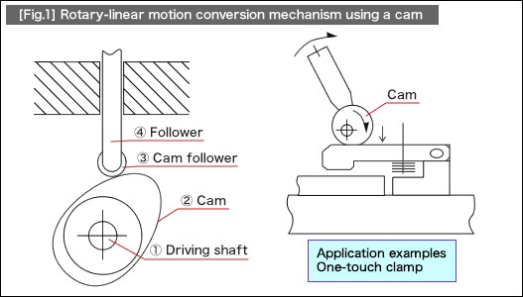

Rotary to linear motion conversion can be configured with a variety of components and achieved with varying degrees of accuracy and strength. We hope that you have been inspired by these simple mechanisms.

### [Rotary to Linear Motion](http://blog.misumiusa.com/rotary-to-linear-motion/)

* [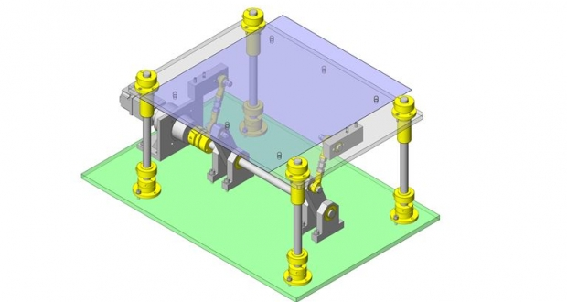](http://blog.misumiusa.com/linear-bushings-more-application-examples/)

QUESTIONS

1.Define motion in engineering

2.Differentiate between linear motion and rotary motion

Top of Form

* 

e

Bottom of Form

Top of Form

Bottom of Form

### 

Top of Form

Bottom of Form